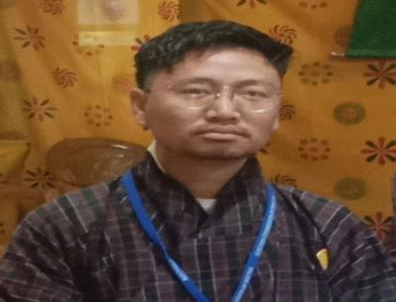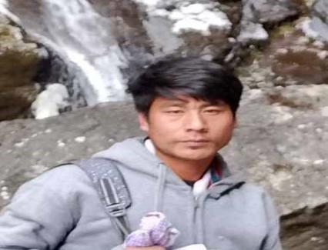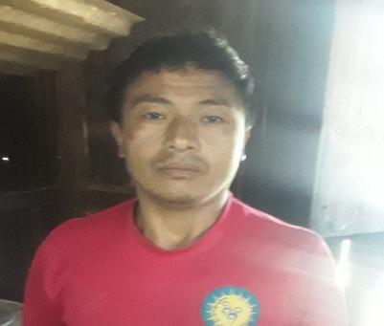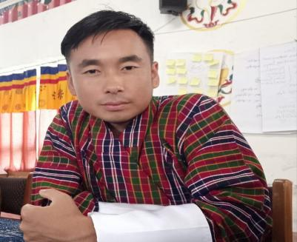

*Sonam Tobgay*

*Administrative Assistant*

*17394188*

*Sonam Wangchuk*

*Sport Instructor*

*17423697*

1796304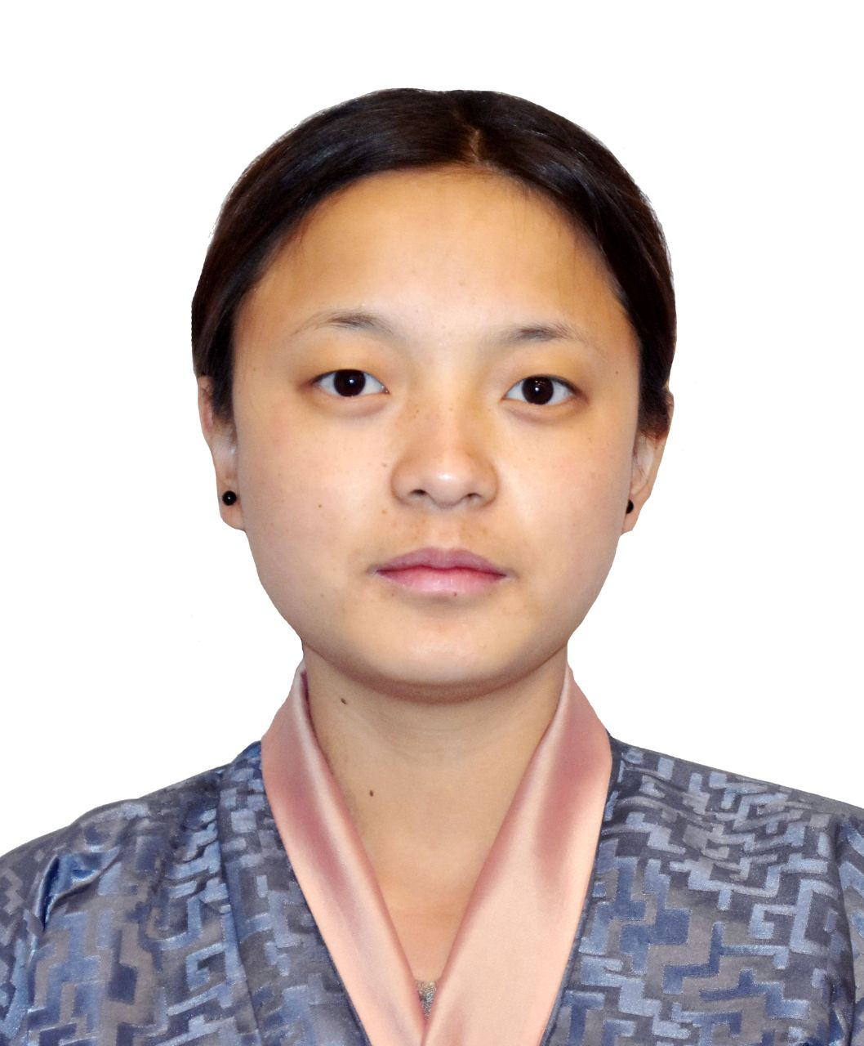8

*Yeshi*

*Caretaker*

*17681212*

*Jabchu*

*Cook*

*17589558*

*Khotsho*

*Cook*

*17933269*

*Pema Wangmo*

*Sweeper*

*17461790*

*Lhab Tshering*

*NFE Instructor*

*17467384*

*Kinley Pelmo*

*CareGiver*

*17963048*

*Kezang*

*ECCD Facilitator*

*17999674*